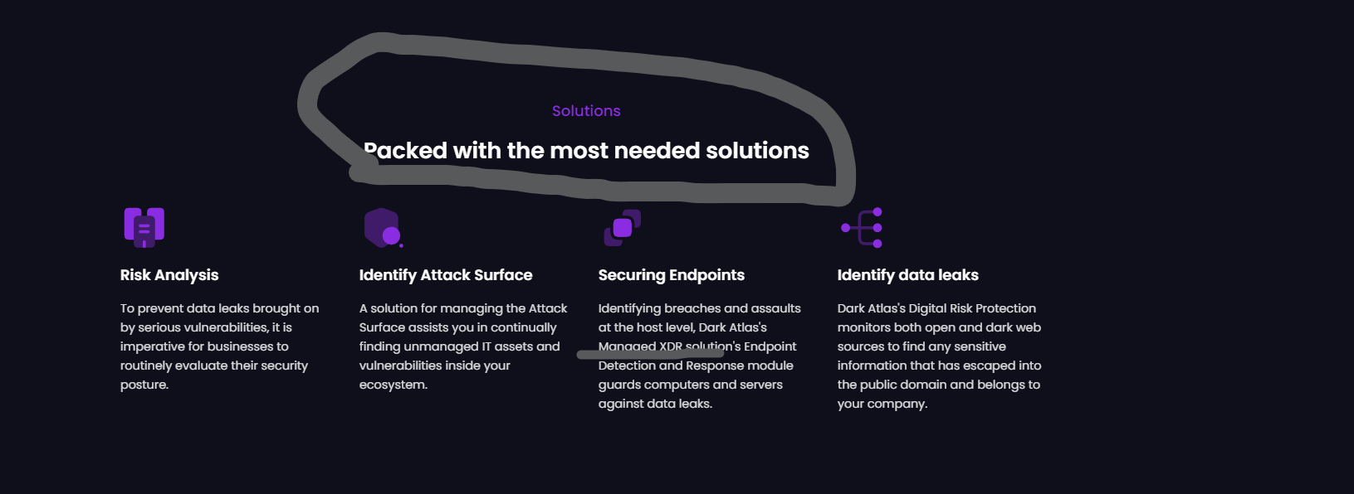

Make Managed XDR > Data Leak Detection

Ransomware

Replace this section by:  
Dark Atlas provides comprehensive ransomware protection by monitoring dark web activity to identify and respond to threats before they reach your systems. Our 24/7 surveillance and advanced analytics enable early detection and quick action, minimizing potential damage and ensuring your data remains secure.

Remove complete page.

<https://darkatlas-landing.vercel.app/solutions/bot-protection>

<https://darkatlas-landing.vercel.app/solutions/cti-program>

<https://darkatlas-landing.vercel.app/solutions/phishing-scam-protection>

remove this section from by industry pages